WEEK:7

1)Write a program that prints the addresses of code, global, static, heap, and stack variables. Analyze the Linux process address space layout and explain each memory segment.

Code:
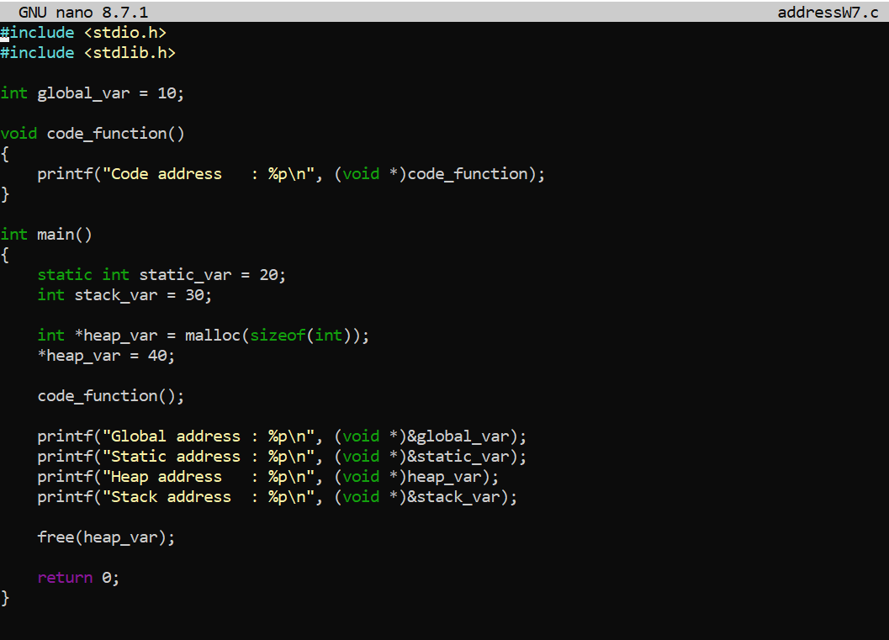

Output:
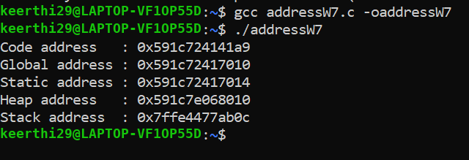

2)Make use of the /proc//maps file and memory analysis tools to study the memory organization of a running process. Prepare a report explaining virtual memory mappings.

Code:
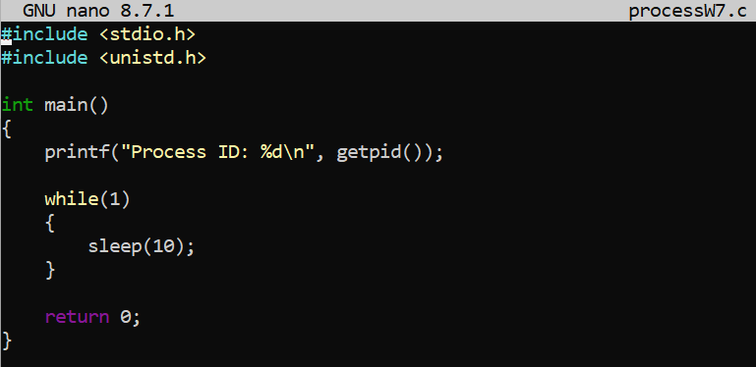
Output:
